V I S I O N

Sta. Rita De Cascia Parochial School is a Catholic School that witnesses to the Gospel, wherein academic excellence, artistic mind, skillful hands and moral uprightness are achieved with critical consciousness and concern for the poor.

M I S S I O N

Sta. Rita De Cascia Parochial School is committed to the total formation of an individual through an integration of faith, morals, knowledge, skills, and culture with active participation in the upliftment of life.

G O A L S

Graduate of SRDCPS:

P - romotes greater academic achievement
through scientific application

O - ffers “ HOTS” ( Higher Order Thinking Skills )

W - itnesses to the Gospel and civic values

E - ngages in community services

R - ( is a ) responsible Filipino; proud of
his/her identity
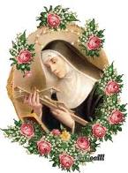

“St. Rita of Cascia, Saint of the Impossible “
Pray for us

Offers the following courses:
Early Childhood Education:
Nursery 3 ½ - 4 years old
Kindergarten 1 4 ½ - 5 years old
Kindergarten 2 5 ½ - 6 years old
Grade School Level:
Primary level Grades 1-4
Intermediate Level Grades 4 - 6

Facilities and Services:
- GENYO E-learning powered by Marshall Cavendish Online based from Singapore
- WIFI Enabled Campus
- CCTV to guarantee your child’s security.
- Fully air-conditioned classrooms with multimedia facilities.
- Computer Laboratory
- Science Laboratory
- Sufficient grounds for play
- Audio-Visual Theater
- Canteen
- Clinic

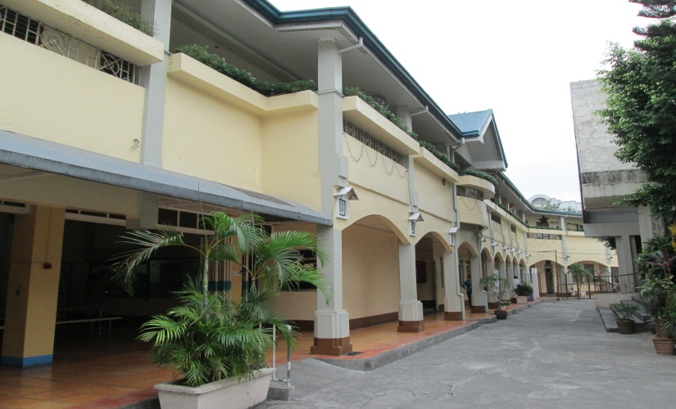

Affordable tuition and down payment:

Early Childhood Education / Grade 1:
5,500 Php. (includes PE Uniform, notebooks and diary)

Grades 2-6 (new pupils):
4,500 Php. (includes PE Uniform, notebooks and diary)

DISCOUNTS FOR EARLY ENROLEES.
ACCEPTS CREDIT CARDS

Sta. Rita de Cascia Parish Compound
Quirino Ave., Baclaran, Paraňaque City
Tel no.: 832-3505
E-mail Add.: srdcps_bac@yahoo.com
Website: www.staritadecasciaparochialschool.weebly.com

Sta. Rita de Cascia Parochial School
formerly “Our Lady of Carmel School”

